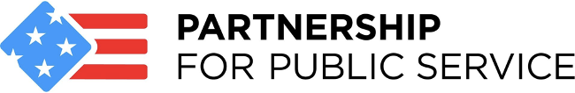

FOR IMMEDIATE RELEASE: December 1, 2021
CONTACT: Austin Laufersweiler
(678) 575-1030

Partnership for Public Service statement on the threat of a government shutdown

WASHINGTON – The nonpartisan, nonprofit Partnership for Public Service today released the following statement from President and CEO Max Stier ahead of the Dec. 3 deadline to fund the government or face a shutdown.

“Our public institutions are losing the trust of the American people,” Stier said. “The threat of yet another government shutdown only further erodes public confidence in our government’s ability to function effectively and solve urgent problems. There is always a place in government for legitimate policy differences that should be discussed, debated and resolved. There is no place, however, for shutting down the government and denying Americans the services they deserve and pay for with their tax dollars.

“While government shutdowns do nothing constructive to advance policy debates, they also do immense harm to the millions of dedicated public servants around the country whose livelihoods are threatened every time Congress plays this game of brinksmanship.

“The challenges faced by our government right now are immense—from a new COVID-19 variant that threatens the progress made to end the pandemic, to multiple pressing national security concerns. Shutting down the government will only make it harder for our country to respond to these threats and keep the American people safe. Our elected leaders owe it to the people they represent to come together and find ways to resolve differences without harming their own constituents in the process.”

The Partnership has extensively studied the significant threats posed by government shutdowns and the reliance on continuing resolutions. See the Partnership’s 2019 report on the effects of the most recent 35-day shutdown, and 2015 study on how uncertainty in the government funding process harms our democracy.

Fiscal year 1997 was the last year that all 12 regular appropriations bills to fund the government were completed by the Oct. 1 deadline. There have been 21 shutdowns of a day or longer since the Carter administration, and dozens more occasions when agencies had to plan for the possibility of one.

During the past 20 years, the nonpartisan, nonprofit Partnership for Public Service has been dedicated to making the federal government more effective. We work across administrations to help transform the way government operates by increasing collaboration, accountability, efficiency and innovation. Visit ourpublicservice.org to learn more. Follow us on social @PublicService and subscribe today to get the latest federal news, information on upcoming Partnership programs and events, and more.

###

